



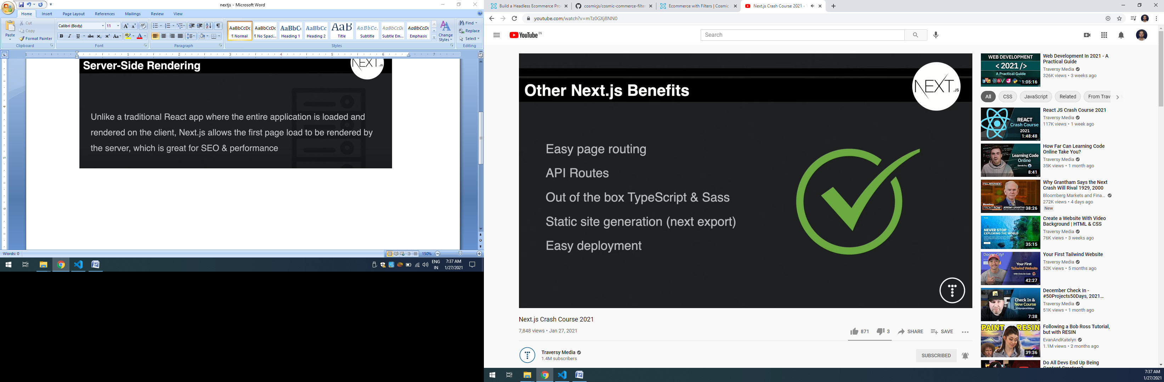

Anything define inside the pages will render like php pages

Example about.js will call in browser url like <http://localhost:3000/about>

Add seo meta tag

